CS4335 Tutorial Week 3

Solution
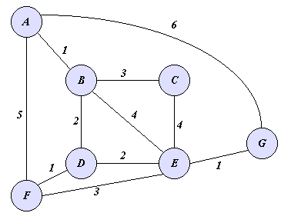
Kruskal
Sort all edges by weight: {(A, B, 1), (D, F, 1), (E,G,1), (B, D, 2), (D, E, 2), (B,C,3), (E, F, 3), (A, B, 4), (C,E,4), (A, F, 5), (A, G, 6)}.
1. Select (A, B, 1)
{A, B}
2. Select (D, F, 1)
{D, F}
3. Select (E, G, 1)
{E, G}
4. Select (B, D, 2), {A, B} connect to {D, F}
5. Select (D, E, 2), {A, B, D, F} connect to {E, G}
6. Select (B, C, 3). Make {A, B, D, F, E, G} connect to {C}

All vertexes are connected. Finally, A = {(A, B, 1), (D, F, 1), (E, G, 1), (B, D, 2), (D, E, 2), (B , C, 3)}
Prim
Start:
Q= {(A, 0, Nil), (B, ∞, Nil), (C, ∞, Nil), (D, ∞, Nil), (E, ∞, Nil), (F, ∞, Nil), (G, ∞, Nil)}
A = empty
(Q’s element: (vertex, key, parent), choose the element with smallest key value in each step)

Step 1. (choose (A, 0, Nil) )
A = empty
Q= {(B, 1, A), (C, ∞, Nil), (D, ∞, Nil), (E, ∞, Nil), (F, 5, A), (G, 6, A)}

Step 2. (choose (B, 1, A))
A = {(A, B)}
Q= {(C, 3, B), (D, 2, B), (E, 4, B), (F, 5, A), (G, 6, A)}

Step 3. (choose (D, 2, B))
A = {(A, B), (B, D)}
Q= {(C, 3, B), (E, 2, D), (F, 1, D), (G, 6, A)}

Step 4. (choose (F, 1, D))
A = {(A, B), (B, D), (D, F)}
Q= {(C, 3, B), (E, 2, D), (G, 6, A)}

Step 5. (choose (E, 2, D))
A = {(A, B), (B, D), (D, F), (D, E)}
Q= {(C, 3, B), (G, 1, E)}

Step 6. (choose (G, 1, E))
A = {(A, B), (B, D), (D, F), (D, E), (E, G)}
Q= {(C, 3, B)}

Step 7. (choose (C, 3, B))
A = {(A, B), (B, D), (D, F), (D, E), (E, G), (B, C)}
Q= empty

